**Software Requirements Specification**

**DevOps Group 3**

**Team Members: Harene d/o Pandi Raj (p2315788)**

**Ezell Low Qing Wei (p2315618)**

**Edward Ti Zhi Hao (p2220400)**

**Lim Jia Ning Vera (p2209278)**

Table of Contents

1. Purpose 2

1.1. Intended Audience 2

1.2. Intended Use 2

1.3. Scope 2

1.4. Definitions and Acronyms 2

2. Overall System Description 3

2.1. Use Case Diagrams 3

2.2. System Architecture 4

2.3. Functional Requirements 5

2.3.1. Start Up and Main Menu 5

2.3.2. Log in to website and start the car ..................................................................................... 8

2.3.3. Lock/Unlock car door and aircon control ........................................................................... 9

2.3.4. Car Theft Warning ………………………………………………………………………………………………………… 11

2.3.5. Remote Access .................................................................................................................. 13

2.3.6. Authentication Services ..................................................................................................... 14

2.3.7 Sequence Diagram ……………………………………………………………………………………………………….. 15

1. Software Architecture .................................................................................................................... 16

3.1. Static Software Architecture ..................................................................................................... 16

# Purpose

## Intended Audience

This SRS document describes the System Requirements and Software Design for a Vehicle Security and Telematics System and the target audience are System and Software Engineers working on the development of this project.

## Intended Use

The SRS defines the overall System Architecture and Requirements as well as the Software

Architecture and Design. This document also contains the definition of the System Requirements which shall be used as the input for System Test cases and Software Unit Test cases.

## Scope

The project will require Engineers to create a website and use the Raspberry Pi 4 to simulate signals of the Vehicle Security and Telematics System.

## Definitions and Acronyms

|  |  |
| --- | --- |
| **Acronym** | **Description** |
| IR | Infra Red |
| LED | Light Emitting Diode |
| NFC | Near Field Communication |
| SW | Software |
| HW | Hardware |

# Overall System Description

## Use Case Diagrams

Vehicle Security System



User



Website

## System Architecture

The System Architecture

Ultrasound Sensor

NOT IN USE

Light Dependent Resistor

Buzzer

Temperature and Humidity Sensor

Switch

User interface

(website)



DC Motor



Servo Motor



Ultrasound Sensor



RFID

Card

Reader



SPI_

SPI_

ADC_CH01

ADC_CH01



I2C



**Raspberry Pi Development Board**



GPIO

GPIO

22

24



GPIO

23



GPIO

26



GPIO

GPIO21

GPIO18

24

\

## Functional Requirements

### Start Up and Main Menu

|  |  |
| --- | --- |
| **REQ_ID** | **Requirement** |
| REQ-01 | When the website is accessed for the first time, it will show a login page. Once the login page is filled in it redirects to the red ‘start engine’ button.  “Email address: ”  “Password: ” |
| REQ-02 | Once the sign up page is filled in, the website redirects to the red ‘start engine’ button.  “Email address: ”  “Password: ”  “Email Address: ”  “First name: ”  “Password: ”  “Password (Confirm): ”  “Verification Code:” |
| REQ-03 | Users can also access the vehicle using an RFID authentication. When RFID card is detected on the reader it automatically redirects to the red button “start engine”. (2 users can use 2 different RFID cards to start the engine) |
| REQ-04 | When the car app is first logged in/user first signs up, the user can press the red button “start engine” to switch on the engine. |
| REQ-05 | If the “start engine” button is pressed, the following menu options will be displayed on the web interface.    “Car Temperature: “  “Fuel level: “  “Theft Warning: Not Triggered ”  “Car door: Lock, Unlock”  “Air conditioning Temperature:” |
| REQ-06 | In the main menu defined in REQ-05, if the option “Lock” is selected, the web interface should display in red,  “Lock” |
| REQ-07 | In the main menu defined in REQ-05, if the option “Unlock” is selected, the web interface should display in red  “Unlock” |
| REQ-08 | In the main menu defined in REQ-08, the desired temperature entered, will be displayed on the web interface and LED turns on to a certain brightness.  “Airconditioning temperature _____ ” |
| REQ-09 | In the main menu defined in REQ-05, if all doors of the car are locked and the door is forcefully opened, it will trigger the car alarm to sound and the web interface should display the menu options with the new following text:  “Car Temperature: “  “Fuel level: “  “Theft Warning: Triggered ”  “Car door: Lock, Unlock”  “Air conditioning Temperature: ” |
| REQ-10 | In the main menu defined in REQ-05, if the option “Enter” is selected for car temperature, the web interface should display the current car temperature  “29 degrees” |
| REQ-11 | In the main menu defined in REQ-05, if the option “Enter” is selected for fuel level, the web interface should display the current car fuel level.  “High” |

### Log in to website and starting the car

|  |  |
| --- | --- |
| **REQ_ID** | **Requirement** |
| REQ-02 | When the website is accessed, it will show a login page.  “Email address: ”  “Password: ” |
| REQ-03 | Users can also access the vehicle using an RFID authentication. When RFID card is detected on the reader it automatically redirects to the red button “start engine”. (2 users can use 2 different RFID cards to start the engine) |
| REQ-04 | When the car app is first logged in, the user can press the red button “start engine” to switch on the engine. |

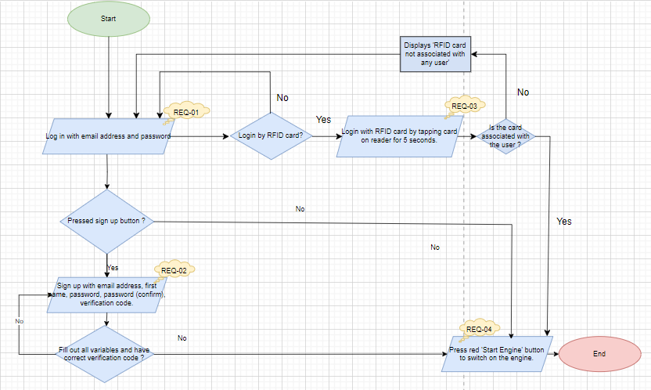

**Figure 1**

2.3.3 Lock/Unlock car door and aircon control

|  |  |
| --- | --- |
| **REQ_ID** | **Requirement** |
| REQ-05 | In the main menu defined in REQ-04, if the option “start engine” is selected on the keyboard, then the following menu shall be displayed on the web interface.    “Car Temperature: “  “Fuel level: “  “Theft Warning: Not Triggered ”  “Car door: Lock, Unlock”  “Air conditioning Temperature: ” |
| REQ-06 | In the main menu defined in REQ-05, if the option “Lock” is selected, the web interface should display in red,  “Lock” |
| REQ-07 | In the main menu defined in REQ-05, if the option “Unlock” is selected, the web interface should display in red  “Unlock” |
| REQ-08 | In the main menu defined in REQ-08, the desired temperature entered, will be displayed on the web interface and LED turns on to display a certain brightness.  “Airconditioning temperature _____ ” |

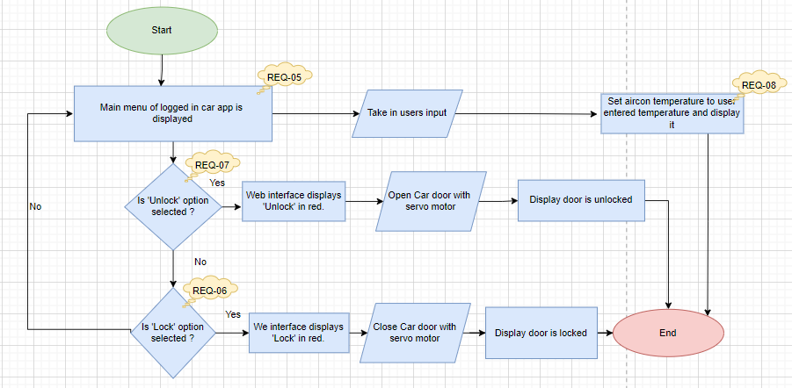

**Figure 2**

2.3.4 Car theft warning

|  |  |
| --- | --- |
| **REQ_ID** | **Requirement** |
| REQ-05 | In the main menu defined in REQ-04, if the option “start engine” is selected on the keyboard, then the following menu shall be displayed on the web interface.    “Car Temperature: “  “Fuel level: “  “Theft Warning: Not Triggered ”  “Car door: Lock, Unlock”  “Air conditioning Temperature: ” |
| REQ-09 | In the main menu defined in REQ-05, if all doors of the car are locked and the door is forcefully opened, it will trigger the car alarm to sound and the web interface should display the menu options with the new following text:  “Car Temperature: “  “Fuel level: “  “Theft Warning: Triggered ”  “Car door: Lock, Unlock”  “Air conditioning Temperature: ” |
| REQ-10 (extra implementation) | In the main menu defined in REQ-05, if all the doors of the car are locked and there is movement detected inside the car, it will trigger the car alarm to sound and the web interface should display the menu options with the new following text:    “Car Temperature: “  “Fuel level: “  “Theft Warning: Triggered ”  “Car door: Lock, Unlock”  “Air conditioning Temperature: ” |

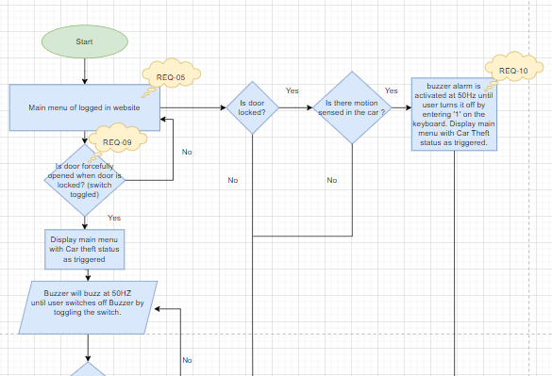

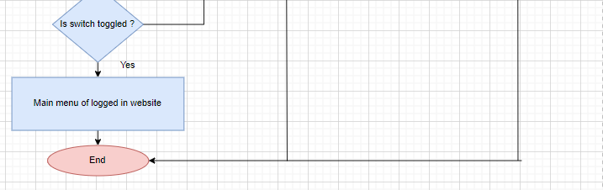

Figure 3

2.3.5 Remote Access

The Vehicle Security and Telematics System supports “Remote Access” to monitor vehicle functions, set events, and control remotely.

|  |  |
| --- | --- |
| **REQ_ID** | **Requirement** |
| REQ-02 | Implement user authentication using login credentials (email address and password) for accessing the vehicle remotely. |
| REQ-03 | Support RFID Card Authentication for quick and easy login. |
| REQ-04 to 11 | Enable remote control functionalities for the driver website, including:   * REQ-04: Starting the car engine. * REQ-05: Displaying main menu. * REQ-06 & 07: Controlling door ‘Lock’ & ‘Unlock’ status. * REQ-08: Controlling air conditioning. * REQ-09 &10: Car break in triggers. * REQ-11 & 12: Monitoring car fuel status and car temperature. |
| REQ-04 | Start the car engine |
| REQ-05 | Display the whole main menu. |
| REQ-06 | Controlling door ‘Lock’ status. |
| REQ-07 | Controlling door ‘Unlock’ status. |
| REQ-08 | Control the air conditioning temperature in the car. |
| REQ-09 | Implement an alarm system that triggers when any door is forcefully opened while all doors are locked. Notify the user via their smartphone on a website of a possible theft attempt. |
| REQ-10 | Extra implementation of alarm system that instead triggers when there is motion detected inside the car while all the doors are locked. Notify the user via their smartphone on a website of a possible theft attempt. |
| REQ-11 | Monitor the current fuel status of the car. |
| REQ-12 | Monitor the current temperature of the car. |
| REQ-13 | Enable the sharing of the vehicle with at least two different drivers using separate RFID cards. |

2.3.6 Authentication Services

In the car application, user authentication is required before accessing its functionalities. This involves a sign up/ log in/ RFID card authentication process to ensure user identity verification.

|  |  |
| --- | --- |
| **REQ_ID** | **Requirement** |
| REQ-01 | Upon launching the web application: The web interface shall display a log in screen prompting users to enter their credentials.  The login screen shall include fields for email address and password. |
| REQ- 02 | If the user has yet to sign up, they can click on the sign up button at the top left corner of the website. The web interface shall display a sign up screen prompting users to enter their credentials.  The sign up screen shall include fields for first name, password, confirm password, email address and verification code. |
| REQ- 03 | Users can also access the vehicle using an RFID authentication. When RFID card is detected on the reader it automatically redirects to the red button “start engine”. (2 users can use 2 different RFID cards to start the engine) |

2.3.7 Sequence Diagram

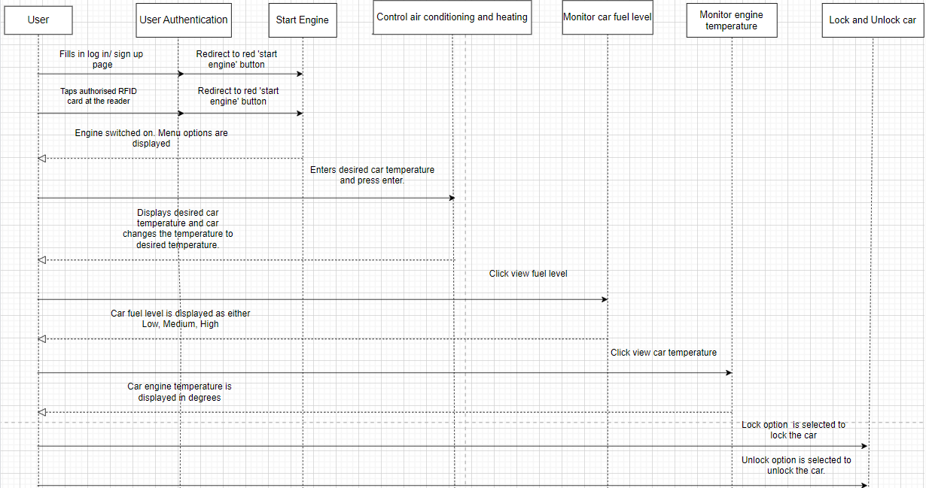 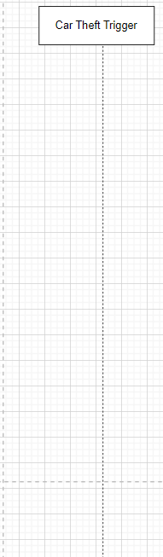

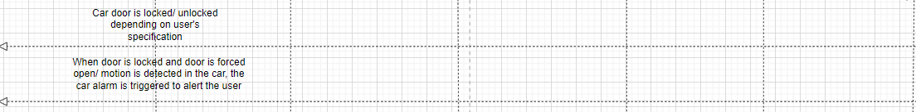 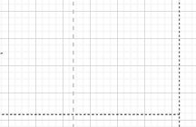

1. Software Architecture

3.1. Static Software Architecture

The Software Architecture defines the various Software Components that are developed to realize the implementation of the system requirements.

Sign_up.html

login.html

home.html

car_menu.html

base.html

Main.py

_init_.py

ultrasound.py

fuel.py

temp.py

rifd_checker.py

aircon.py

Door.py

engine_sim.py

auth.py

views.py



**Application**

**Layer**

**Hardware Abstraction Layer (HAL)**

RFID cards

Switch

Wifi

DHT11

Light Dependent Resistor

Ultrasound Sensor

LED

DC Motor

Buzzer

Servo motor